Unit 3. Size of Objects
Purpose: comparison of objects’ sizes by application (overlay) method; defining the size of an object in words «of the same size».
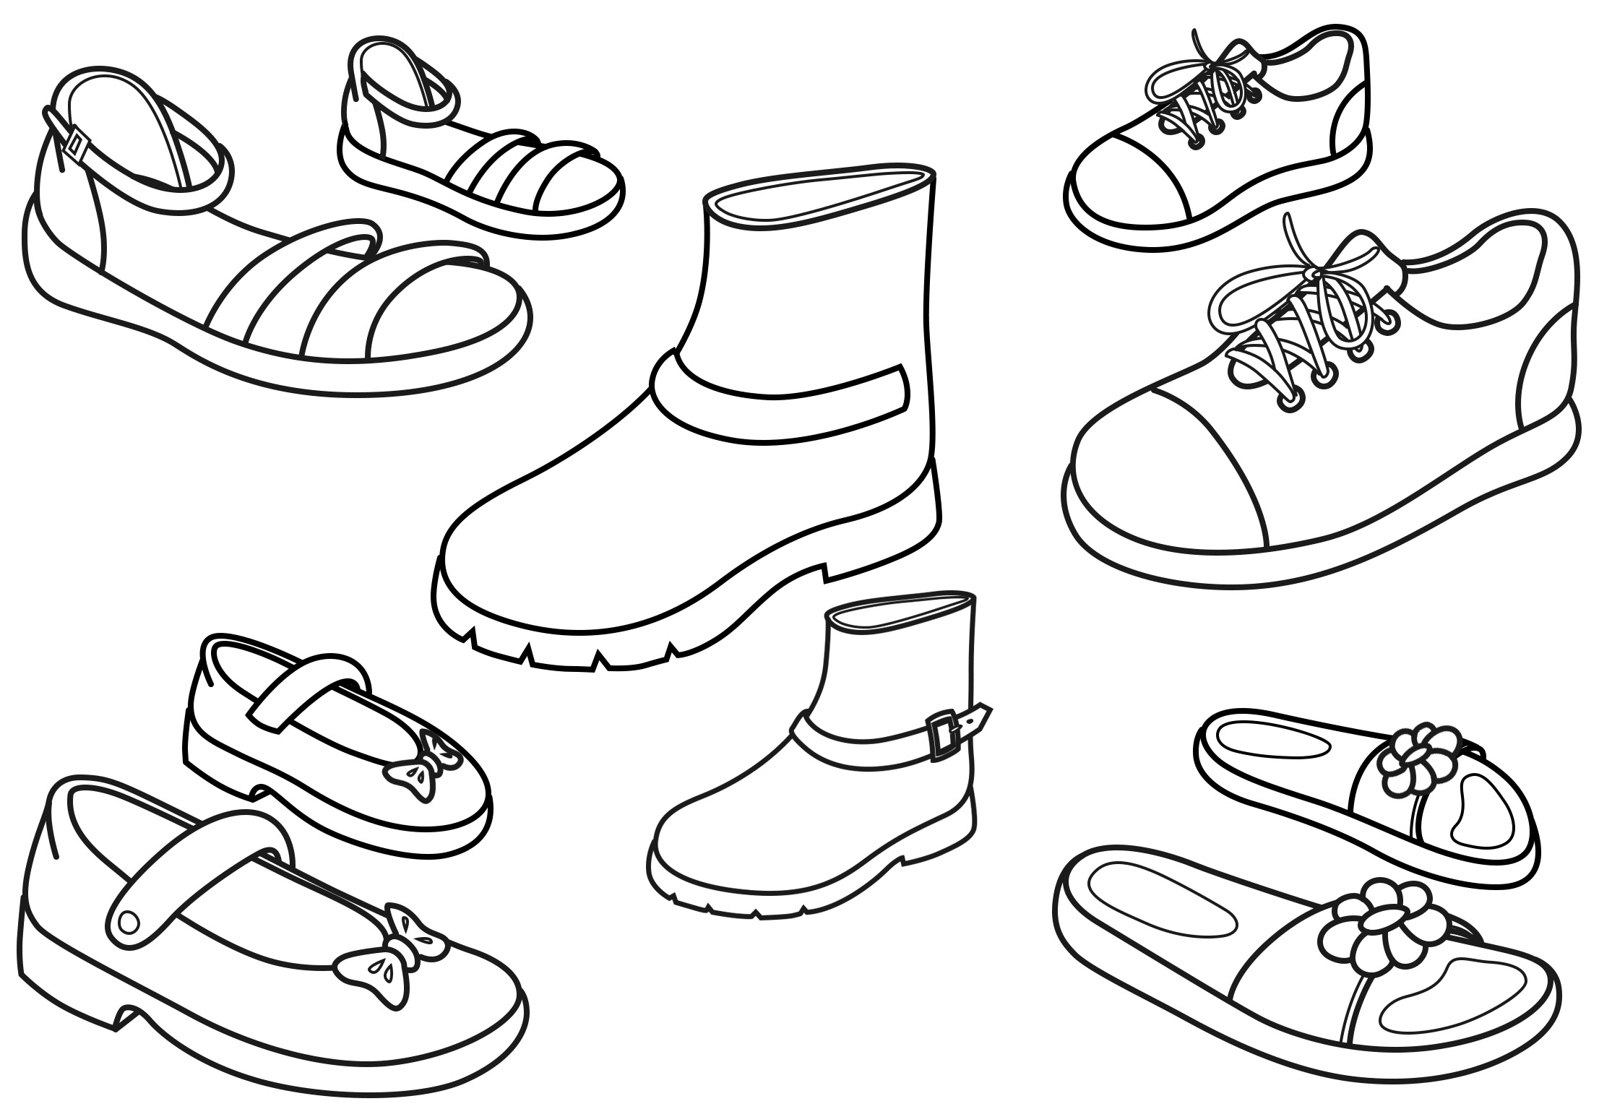 | Educational dialogue:  Name the objects in the picture. (Boots, shoes, sandals, slippers, gym-shoes.) How can we name all these things in one word? (It is footwear.) What is the painter’s mistake? (The painter painted boots, shoes, slippers, gym-shoes of different size.) Take your, your mother’s, your father’s shoes and compare their sizes. Put the slippers one to another, sole to sole, in such a way that their edges from one side should coincide. Look whether the edges from another side coincide too. If it is so, the slippers are of the same size. Are the shoes of the same size for the legs of one person? (The shoes for the legs of a person are of the same size.)  Why shoes are made of the same size? (Because one person’s feet are of the same size.) Outline with a pencil your feet on the paper. Cut out these pictures and compare their sizes. Are your feet of the same size? (The feet are of the same size.)

Unit 5. Longe – shorter
Purpose: comparison of objects’ length by application (overlay) method; defining an object’s size with words «longer – shorter».
Material: 5 paper stripes-boards – Appendix 2.
Educational dialogue:
Finish the stairs. You have the strips of paper-boards. Put them in front of you. Show the length of these boards. What can you say about the boards’ length? (There are boards longer and there are boards shorter in size.)
You should choose out of the boards those that are shorter in size. How can you find them? (Put one board to another in such a manner that their edges on one side should coincide. Put your finger on the edge of the boards where they coincide. Move your finger along the length. One board has already ended, it is shorter. Another board still extends further, it is longer.) You should choose out of the boards the ones that are shorter, and paste them on the stairs.
Boards of which length did you choose? (Shorter ones.) Boards of what length remain? (Longer ones.)
How can you determine the size of things? (To put one thing to another.)

Table of Contents

Foreword
Unit 1. Concept of «Object»
Unit 2. Size of Objects
Unit 3. Size of Objects
Unit 4. Higher - Lower
Unit 5. Longe – shorter
Unit 6. Wide – Narrower
Unit 7. Space: Above, Below
Unit 8. Space: Ahead, Behind
Unit 9. Space: Left, Right
Unit 10. Space
Unit 11. Space: In, On, Between, Across
Unit 12. One – Many
Unit 13. One – Many
Unit 14. One – Many
Unit 15. One – Many
Unit 16. One – Many
Unit 17. Multitudes of Equal Quantities
Unit 18. Multitudes of Equal Quantities
Unit 19. Neighboring multitudes

Unit 20. Neighboring and Equal Multitudes
Unit 21. Multitudes of Equal Quantities
Unit 22. Figure «1»
Unit 23. Figure «1»
Unit 24. Numbers «оne», «two»
Unit 25. Figure «2»
Unit 26. Figure «2»
Unit 27. Number «Three»
Unit 28. Number «Two»
Unit 29. Figure «3»
Unit 30. Number «four»
Unit 31. Number «3»
Unit 32. Figure «4»
Unit 33. Figure «4»
Unit 34. Number «five»
Unit 35. Number «four»
Unit 36. Figure «5»
Unit 37. Numbers and Figures
Unit 38. Counting Out of Things
Unit 39. Ordinal сounting
Unit 40. Ordinal сounting
Unit 41. Numbers and Figures
Unit 42. Ordinal Counting
Unit 43. Day Part – Afternoon
Unit 44. Day Part – Night
Unit 45. Day Part – Morning
Unit 46. Parts of Day – Evening
Unit 47. Parts of Day
Unit 48. Parts of Day
Unit 49. Parts of Day
Unit 50. Yesterday, Today, Tomorrow
Unit 51. Point (Dot)
Unit 52. Line (Straight, Curved)
Тема 53. Segment
Unit 54. Line (Broken)
Unit 55. Ray. Angle
Unit 56. Polygons
Unit 57. Triangle, quadrangle, pentagonal Unit 58. Form of Things
Unit 59. Rectangle
Unit 60. Square
Insert – Appendices

Dear parents!
The tasks of this work sheet secure:
formation of math notions of quantity, form, size, space, and time;
development of logical thinking – children will learn to analyze, to synthesize, to conclude, to generalize, to substantiate the choice of their way of solving a certain task\test;
communication skills development – children will master the skill of story composition (action, descriptive), exchange their views on study material; get information for solving the tasks; agree the numerals in gender, number, and case with the nouns;
moral education – practical situations will help to form in children a wish of assistance, responsibility, discipline, kindness;
creativity – the tests require quick mind, cognitive skills, originality in observing things and phenomena, imagination, fantasy;
enrichment of a child’s knowledge about different spheres of the world (nature, society, variety of things);
cognition of the world as a whole phenomenon, understanding of maths as a characteristic of the quantitative side of things and events.
The tests of the work sheet are based on development technologies:
- content generalization (V. Davydov, D. Elkonin),
- genesis of dynamic image (M. Rychyk);
- essence and interrelation of knowledge and thinking (E. Ilienkov),
- process nature of scientific knowledge (H. Shchedrovitsky),
- activity integration (A. Losev),
- development education (I. Bekh).

How to work with the tests?
Before the lesson, suggest the child to cut out of the appendix the things required for solving the task.
Advise the child to look at the picture with much attention.
Ask question after question with sufficient time interval, one by one, not all at once.
Do not hurry to answer all the questions, give the child an opportunity of performing the test in his\her own way, support his\her intention to think, to express his\her own point of view.
Do not criticize a child’s ideas, even if you perceive them as absurd or unrealistic.
Offer your variant of a test’s solving. Discuss each act while solving.
After a dialogue, ask the child what he\she would like to know else.
If a child has such a wish, he\she can paint a picture, compose a story after a picture, imagine the beginning and the end of the narration.
One test can require several days to complete.

After completing a task, ask the child to assess the work using the stars:
Right solution – paint a star blue.
Accurate solution – paint a star yellow.
Original solution – paint a star violet.
A child can paint more stars, if he\she finds out another criterion of performing a task. For example, when he\she asked additional questions – a green star, when he\she was attentive – a pink star.
In no way a child should get a negative response. Positive encouragement secures personal evaluation method, provides the possibility of comparison of a child’s former achievements with his\her current ones.

